PCB Work

Compensation - $20/hour - expected time required for each part is listed

Projects listed in order of importance for completion

**PCB #1 – Generic Power PDB**

**Description:**

Simple 36mm square board meant for power distribution in a multirotor. An onboard 5V regulator as well as several headers.

**Specs:**

-36mmx36mm board  
-30A/pad set capable  
-5V 3A BEC  
-Headers for VTx and cam, with the ability to select 5V or filtered supply voltage (or 12V with the addition of a 12V step up)  
-filtered supply for BEC and VTx/cam  
-Two 5V headers for FC and other electronics (could power a GoPro or Mobius)  
-Header for 12V step up (designed around the Pololu 12V step up)  
-Video header for OSD or jumper for straight through

**Work to be completed (expected time – 1 hour):**

Board fully designed in Eagle but it needs a new 5V IC substituted for the current one (it was too expensive to produce). A new DXF board outline may need to be imported. A general sanity check should be done to ensure the board will work as expected.

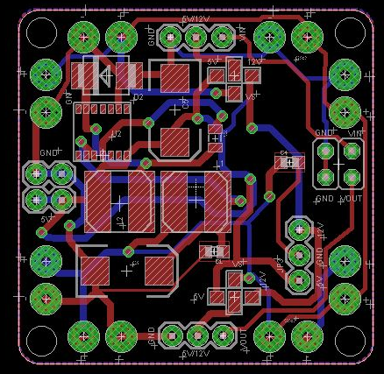 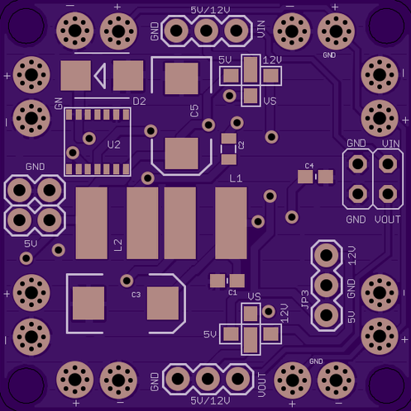

**PCB #2 – Morphling PDB**

**Description:**

Custom PCB design for a mini multirotor to add several important features, including regulated and filtered voltages as well as video overlays and LEDs.

**Specs:**

-Custom board outline  
-30A/pad set capable with signal lines  
-5V 5A step down switching regulator and 12V 1A step up reg (from 5V)  
-Headers for VTx and cam, with the ability to select 5V, 12V or filtered supply  
-filtered supply  
-Headers for OSD (onscreen display) chip integration

-Headers for interfacing with flight controller

-Multicolor LEDs on dipswitches

**Work to be completed (expected time – 4 hours):**

Board prototype designed and made. Several issues apparent. Needs some major revisions, including a new board outline, several change components, several new components, and moving a bunch of stuff around.

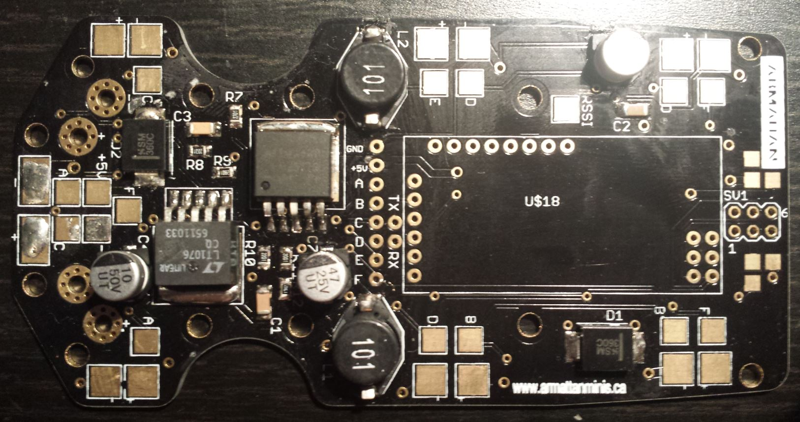

**PCB #3 – Electronic Speed Controllers**

**Description:**

New ESC (electronic speed controller) with new FETs and logic chips. Many current designs use older hardware that can be improved upon. Have firmware developer available.

**Specs:**

-12A Brushless ESC (maybe 18A and 24A as well)

-New FETs (such as <http://www.onsemi.com/pub_link/Collateral/NCP5911%20DS.PDF> )

-50MHz SiLab MCU (‘F390)

**Work to be completed (expected time – 5 hours):**

Complete ESC design, just the wanted specs are known at the moment. If interested, will interface with firmware developer (he knows a lot about what components to use) to determine exact spec list and deliverables.

